Telefund Data Analyst

Key Tasks and Responsibilities

Contents:

General Guidelines: 2

Responsibilities and Tasks of the Telefund Data Analyst 2

Qualifications 2

Tips and Helpful Resources 3

Updating this Document 3

Monday Tasks: 3

Weekly Telefund Report 3

Failed Emails 3

Telefund Campaign Data Report 5

Telefund Demographic Report 7

Telefund Key Indicator Report 8

Pledge Reminders 9

Leaderboard 9

Inventory 12

Performance Management 12

Introduction 12

Caller Portal 12

Updating Caller Portal 12

Using Caller Portal 12

Diagnostics and Changing Caller Portal 12

Caller Portal Back End 12

Calling Statistics 12

End of Semester Evaluations 13

Mock Call Analysis 14

Reconciliation of Campus Call and One-Accord Records 14

Introduction 14

Reconciler R-Script 14

Procedure for Running the Script 15

Debugging Common Issues in the Script 17

Retraining App 18

Scheduling 18

Updating the Schedule 18

General Guidelines:

## Responsibilities and Tasks of the Telefund Data Analyst

The Telefund Data Analyst assists the Annual Giving Specialist and Annual Giving Telefund Manager in completing projects, creating reports, and other tasks that the Managers assign. The Data Analyst, as compared to the Student Assistant, reports directly to the Annual Giving Specialist and focuses more on the technical side than human resources.

The key tasks that the Data Analyst regularly performs are as follows,

* Completing the Weekly Telefund Report
* Managing Failed Emails
* Mailing Pledge Reminders
* Keeping an up-to-date Inventory of all Telefund Equipment
* Conducting and Evaluating Surveys
* Determining Peak Performers & Most Improved for MTMs
* Maintaining and Processing End of Semester Evaluations
* Providing statistically-backed advice for improving training and hiring processes
* Performing Statistical Analysis on Caller Stats
* Creating and maintaining spreadsheets (and other tools) to track caller performance
* Reconciling Campus Call and One-Accord Records daily
* Completing Assigned Projects

## Qualifications

* Competence in Microsoft in Excel, Word, and Outlook
* Experience in coding, preferably R programing
* Knowledge of Statistical Methods
* Organization Skills
* Problem solving Skills
* Presentation and Communication Skills
* Efficiency-minded
* Can work on multiple projects at the same time
* Must be able to work for at least 12 hours a week, 2-3 hrs of which must be on Monday

## Tips and Helpful Resources

* Use an organizer to stay on top of all of the required tasks. I highly recommend using the website [trello.com](https://trello.com) . This program makes keeping track of all active projects and weekly tasks easy, which is essential to being effective in this position.
* Make Google your best friend. If you don’t know how to do something, first consult google before asking for outside help. Many problems can be solved easily and quickly looking it up first.
* Stay organized! There are a lot of files to manage in this position and if those files aren’t intuitively organized problems will arise.
* R is the primary programming language I used to perform the tasks in this manual. If you don’t yet have a full grasp on the language there are a lot of resources on the internet to help you get better. I would recommend consulting the e-book at this website <https://r4ds.had.co.nz/> for general learning and using Stack Overflow for specific questions.
* The CampusCall manual saved with this manual provides information on how to use CampusCall and ReportsPlus.

## Updating this Document

* Feel free to add or take from this document as responsibilities are created or become irrelevant. This document should reflect the current responsibilities of the Data Analyst

Monday Tasks:

## Weekly Telefund Report

Every Monday the Telefund Data Analyst prepares three brief reports for various individuals in Philanthropies. These are the Failed Email Report, Campaign Data Report, and Reconciliation Report. They each go to different people: the first goes to Technology & Data Services (current contact Cathy Holcomb), the second goes to the annual giving specialist in the telefund and the telefund manager (Amy and Ted), and the third goes to Finanace (current contact Janae Winsor).

## Failed Emails

Pulling failed emails uses Regular Expressions (Regex) through R programming. The script to do this has already been created in RStudio, so no knowledge of Regex is necessary to complete this task, but basic information about Regex can be found [here](https://www.computerhope.com/jargon/r/regex.htm).

1. Open Outlook and go to the “Failed Emails” tab under Data Assistant
2. Press Ctrl + A to select all of the emails
3. Click File, Save As, then save as “RawEmails [Date]” (date following standard format of MMDDYY) in the Data Assistant Files > Telefund Weekly Reports > Failed Emails Folder
4. Open RStudio.
5. If the “Failed Emails Script.R” Is not open, open it through file directory in the bottom right pane
6. Once the script is open, source the code by pressing CTRL + SHIFT + ENTER all at the same time. The Console box on the bottom left will then prompt you to enter the date specified on the RawEmails text file.
7. Enter in the date and press Enter to continue running the script.
8. If the previous steps were done correctly there should be a new csv file in the Failed Emails folder called “FailedEmails[Date].csv”
9. Close RStudio and open the csv file in Excel
10. Check and fix any errors in the csv (ie, emails not having a label, formatting errors)
11. Save the document and email it to Technology & Data Services (current contact Cathy Holcomb).
12. Afterwards return to the failed emails folder in Outlook and delete/archive all the emails that were just processed.

## Telefund Campaign Data Report

This weekly report contains information from every segment the Telefund has called since 2015. The information in this report is reviewed by the head of Annual Giving and is used to form pivot tables on the Telefund’s performance.

The Data Analyst is primarily concerned with the Table Data tab and updates this list on a weekly basis. Under “Telefund Weekly Reports” in the “TF Campaign Data” Folder there is a historical record of each weekly update.

The only columns that need to be updated in that sheet are highlighted blue.

1. In the “TF Campaign Data” Folder create a copy of the most recent “TF Campaign Data [Date]” and rename it to reflect the current date (in DDMMYY format).
2. There are two key tasks: Add new segments started in the previous week and Update any segments that were called in the last week.
3. First to see which segments were added in the previous week open the “APPEAL CODES Document” kept on SharePoint > Management > Campaigns >
4. This document contains columns related to each institution the Telefund calls on behalf of and the date started. Check for every school if any new segments were started in the previous week.
5. If there are new segments add them to the Campaign sheet following the naming scheme used in the rest of the document. Include from the APPEAL CODE Doc:
   1. Institution
   2. Segment Name
   3. Begin Date
   4. Total Prospects in the Segment
6. After checking the “APPEAL CODES Document” open CampusCall and go to the Online Statistics page and select the Caller Portal stat configuration.
7. Set the dates to start from the beginning of the current year to the current date.
8. Use the stats display and the segments selection option to fill in the remaining data
   1. System Time (system hours in CampusCall)
   2. Talk Time
   3. Dials (total attempts in CampusCall)
   4. Contacts
   5. Credit Card # (credit card count in CampusCall)
   6. Combined # (specified pledge in CampusCall)
   7. Credit Card $ (credit card amount in CampusCall)
   8. Combined $ (specified amount in CampusCall)
9. Occasionally the formatting of the columns may become incorrect and to fix this select a row that is formatted correctly and auto fill all the incorrect cells. After this right click on the little box that will show up to the auto filled cells and select “Fill Formatting Only”.
10. Save the document and include it in the emailed report to the Annual Giving Specialist.

## Telefund Demographic Report (No Longer Produced after 2018)

The Demographic Report tracks the number of updates made to prospect records by callers in the previous week. It utilizes Reports Plus which uses the same login as CampusCall to access.

1. Create a copy of the most recent demographic report located in Telefund Weekly Reports > TF Demographic reports, and rename it to match the current date in MMDDYY form.
2. Login into Reports Plus (which is accessible as a bookmark or desktop shortcut on most of the leadership computers).
3. On the far left is a “Reports” menu. In that section select Daily Reports > Change Demographics Report.
4. Click the select projects button and update the list to match the active projects.
5. Select all of the projects and change the Report Options (on the far right) to show one per page and not show every field for ***each report*** (changing this speeds up the report retrieval time significantly).
6. Additionally: With projects that have been active for a long period of time or have many prospects within (i.e. BYU Loyalty or BYU GOLD). It can be helpful to change the time period option in the bottom setting box from “Project Summary” to specific dates. This will also speed the process significantly.
7. Each project will open a new tab, once a tab is loaded check the number of pages the document has. This number is the number of demographic updates made on that project. Update/Add this number in the Demographic Report file created earlier.
8. Repeat for all of the active projects.
9. Save the document and include it in the emailed report to the Annual Giving Specialist.

## Telefund Key Indicator Report (No Longer Produced after 2018)

This report draws from the Campaign Data and Demographic Reports. It simply records the number of contacts, credit card pledges, and regular pledges in the current year for each institution through the current week. As such, this is the final weekly report.

1. Copy the previous week’s Key Indicator Report and rename it as “Telefund Key Indicators – [Date]” (The date should follow the MMDDYY format).
2. 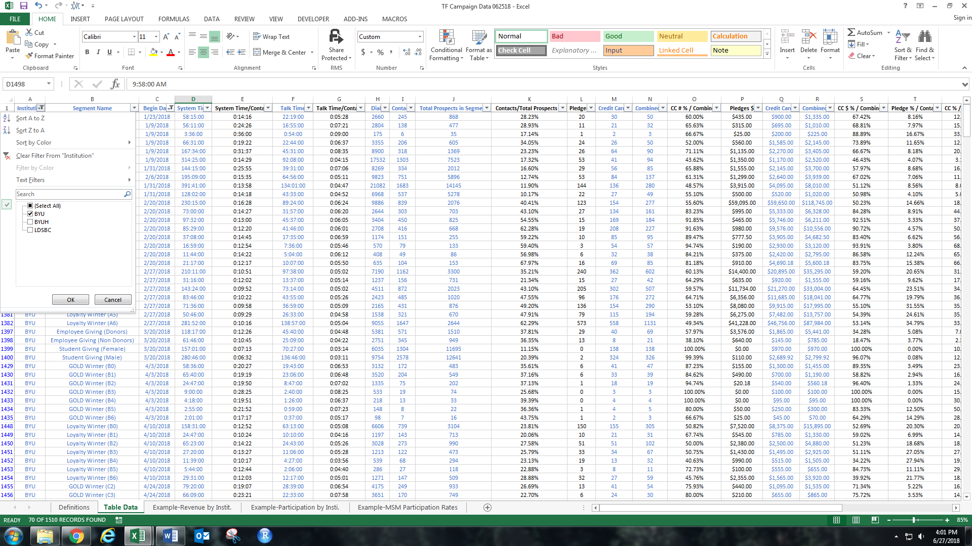Open the current week’s Campaign Data Report, using the filter feature specify the institution and the current year (i.e. BYU and 2018).
3. After filtering the Data, select the entire Contacts column; the sum of the column will display on the bottom green bar. Use this value to update the corresponding cell on the Key Indicator Report.
4. Repeat this process for each key indicator and institution. When finished **DO NOT** save the Campaign Data Sheet – filters may damage the pivot tables.
5. Do the same process to find the total number of demographic updates on the Demographic Report.
6. Save the document and include it in the emailed report to the Annual Giving Specialist.

## Pledge Reminders

The Data Analyst stuffs and mails pledge reminders. Supplies are under the southern most leadership computer desk.

1. Stuff the envelopes.
2. Take a green fund account paper (found in the supplies drawer) and attach one to the group of envelopes with a rubber band.
3. Place in the outgoing mailbox in the LDSP mailroom.

## Leaderboard (Old project, no longer used)

The Leaderboard gives callers an opportunity to see where they stand in the Telefund. The top five in five categories (Pledge Rate, Card Rate, Charges per Hour, Amount Per Hour, and System Time) are posted as well as weekly stats.

Producing the Leaderboard involves running an R script, but no knowledge of the programming is required.

1. Open Excel and create a new spreadsheet; then, using the Caller Portal stats configuration, pull weekly stats and run the macro in the new spreadsheet. Print this spreadsheet to post on the Leaderboard
2. Save the file under Telefund Weekly Reports > Leaderboard > Weekly Stats as a **CSV file** with the name being the dates in MMMDDMMMDD format.
3. 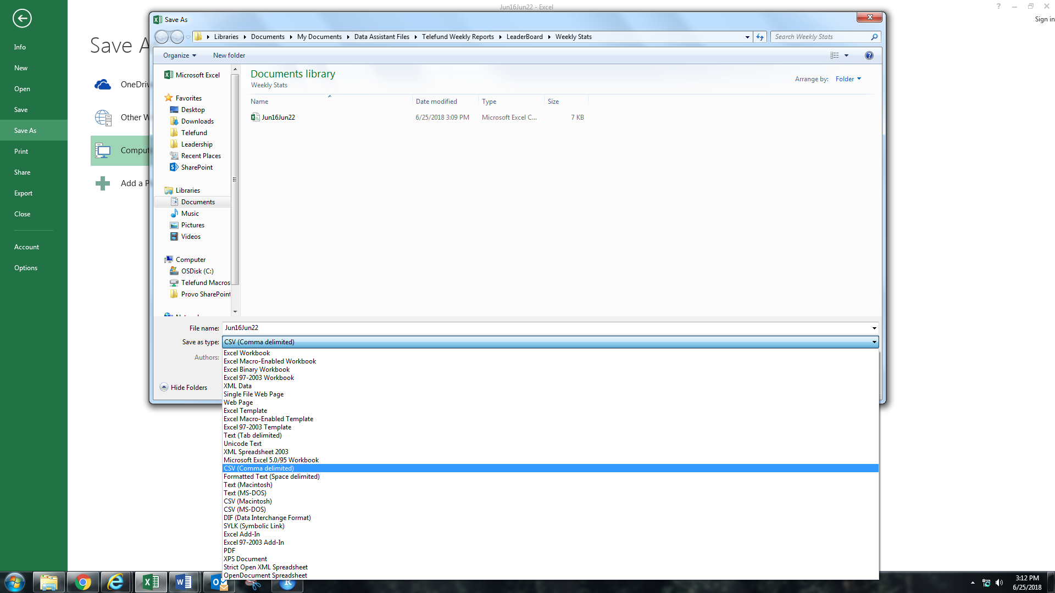Open the R script “Leaderboard Table Maker” in the Leaderboard folder
4. Several Lines of script need to be edited first before running the code to reflect the current week. First there are three lines of code at the top that have to do with what file is being read. These need to be changed to reflect the spreadsheet create in the previous steps

*Also if minimum required call time needs to be changed, change the value in the other circle

1. 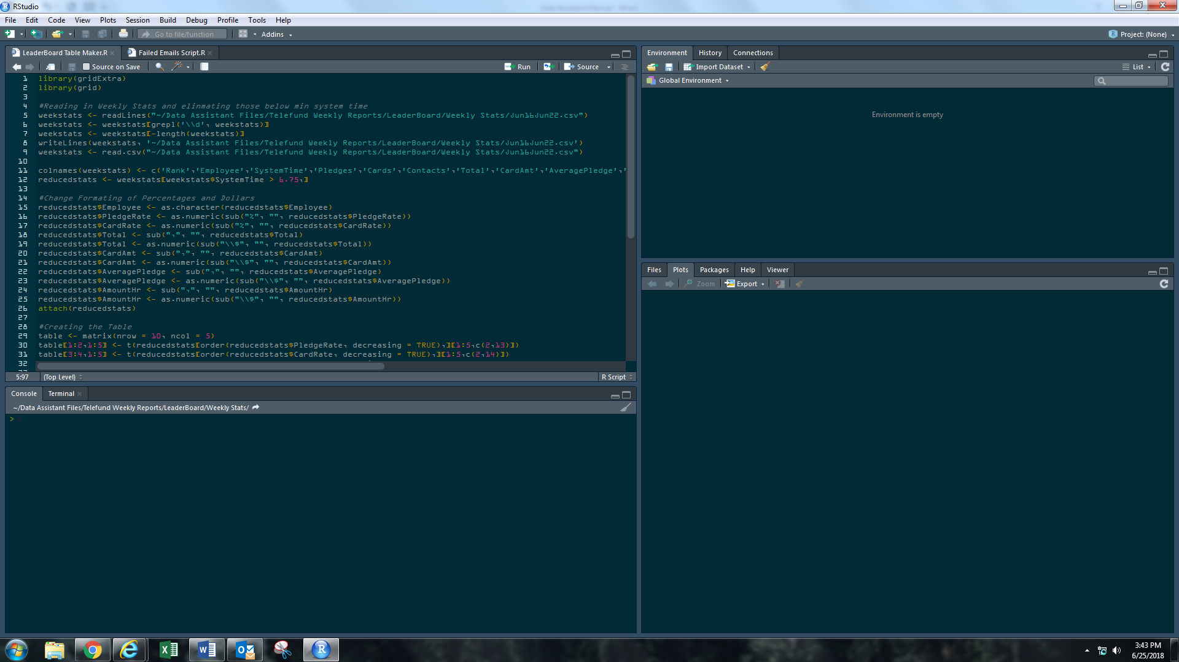Near the bottom of the script change the title of the table by editing this text:

*Also can edit the line under to change note on system time requirements

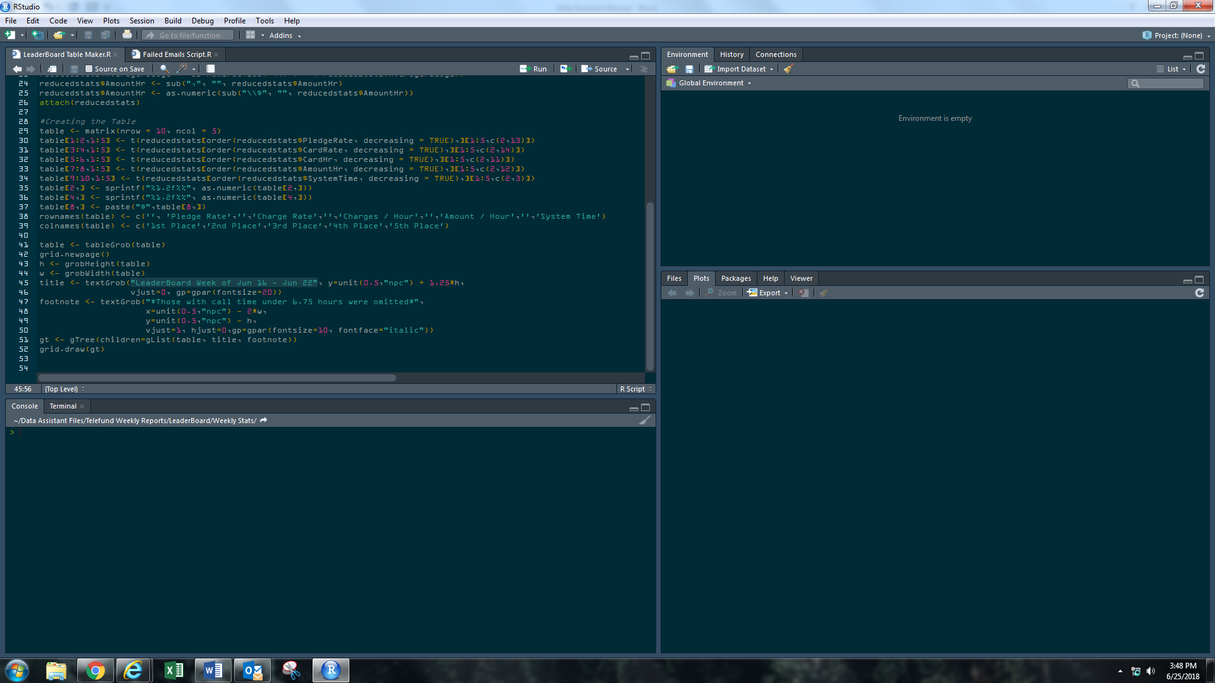

1. Press Ctrl + A to select all the text then Ctrl + Enter to run the script. Once the script is run it should produce a plot similar to the one below.

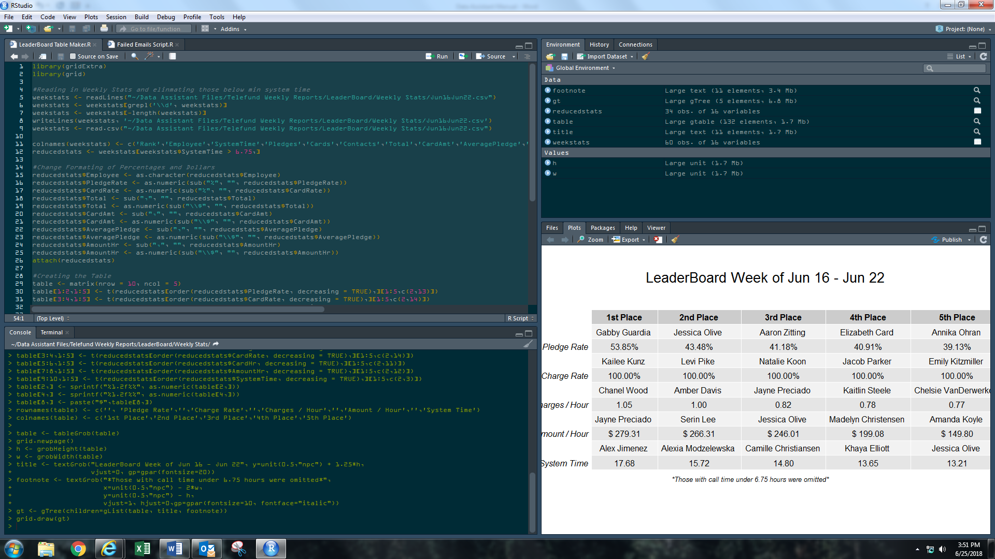

1. 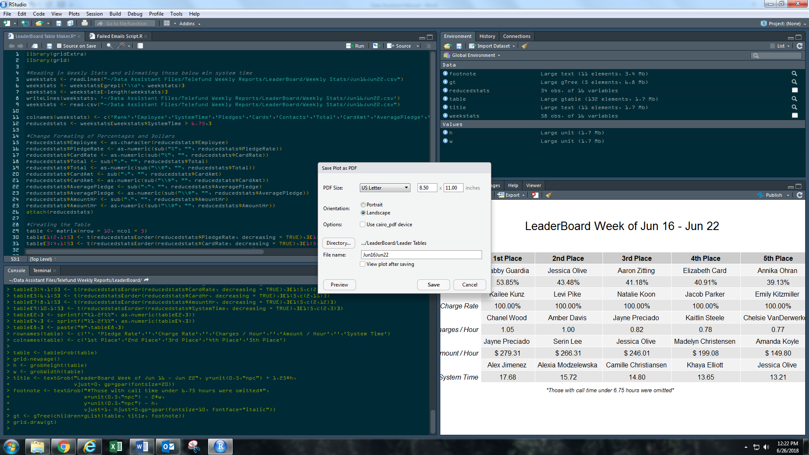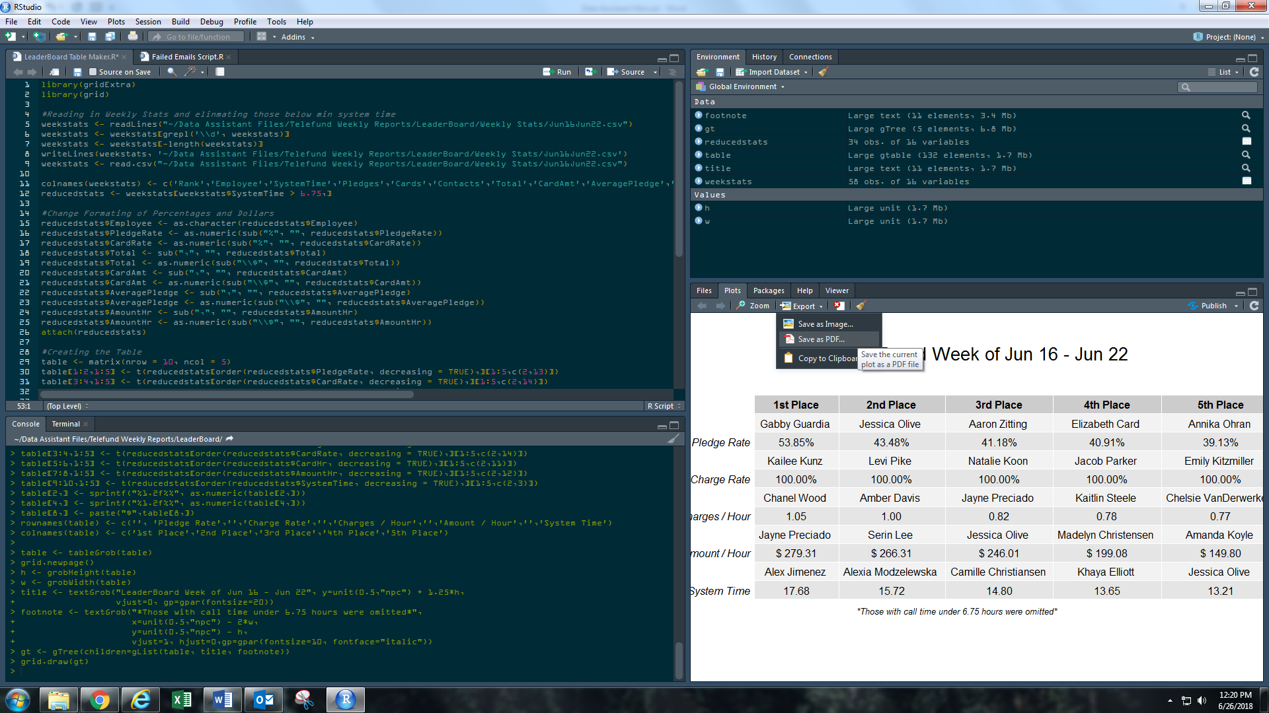Click the Export button and save as a PDF. Use the settings shown in the box below. Name it as the dates MMMDDMMMDD
2. Open this file and print it to update the Leaderboard on the wall

Inventory

The Data Analyst is responsible for keeping the Telefund Inventory up-to-date. The full inventory is located on Sharepoint and keeps track of active, back-up, and retired equipment.

Performance Management

## Introduction

A key task of the Data Analyst is to aggregate all of the data collected on student employees to comprehensively study employee performance. These data are used by student supervisors to assist their teams and by the Annual Giving Specialist and Annual Giving Telefund Manager to make hiring, promotion, and employment decisions.

It is essential that the data collected is presented succinctly so that accurate decisions can be made. As such, the Telefund Data Analyst seeks to maintain and improve the tools supervisors and management use. These tools include Caller Portal, End of Semester Evaluations and Mock Calls.

## Caller Portal

Caller Portal is an excel workbook used to present caller performance data concisely. Beyond displaying in depth data and charts for each individual caller, Caller Portal also provides some tools to measure the overall health of the Telefund.

Caller Portal gives an objective ranking of each caller compared to the fellow callers and is used to determine the performance aspect of employee raises.

## Updating Caller Portal

The Data Analyst adds weekly stats to Caller Portal every week. See the section “Calling Statistics” for information on how to pull weekly statistics. After processing the data add the weekly stats to the corresponding sheet on the master copy of Caller Portal. This copy is located in the Data Analyst files in Caller Portal > Master Copy.

After adding the stats, lock the worksheet with the new stats to prevent editing (under the “Review” tab). The PIN I used on these sheets and throughout Caller Portal is the current year (“2019”). I recommend keeping it simple and recording it so it is not forgotten. Also keeping an up to date unlocked copy would be a good idea as a backup.

## Using Caller Portal

## Diagnostics and Changing Caller Portal

## Caller Portal Back End

## Calling Statistics

CampusCall provides a simple interface to track calling statistics with out accessing ReportsPlus. This interface forms the basis for tracking employee performance in the Telefund whereas ReportsPlus is better suited for project-based reporting and data queries.

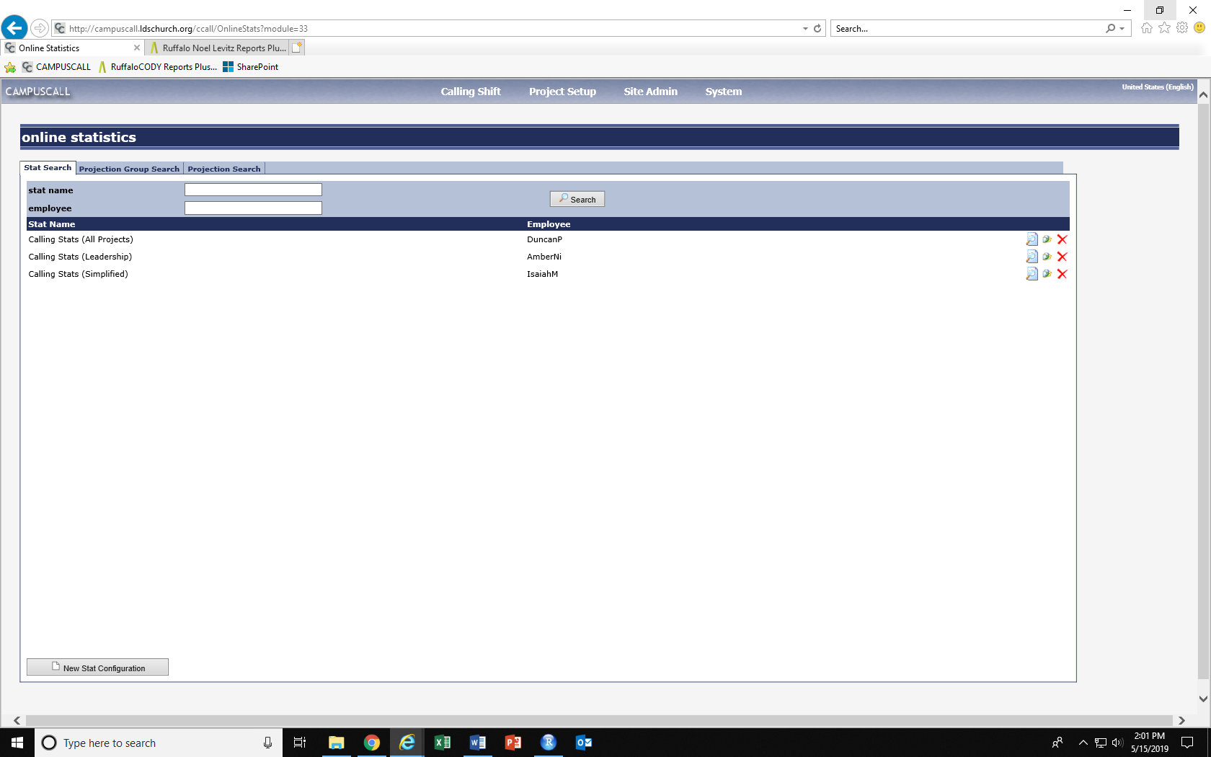To access this interface login in to CampusCall and under the Calling Shift tab select Online Statistics then click the search button which will return a screen similar to this:

This page shows all the different stats views that are avaliable for use. To learn more about how to create and update these views refer to the CampusCall Manual (either on SharePoint or google search it).

There are three general stats views. They are the Calling Stats – All projects, Leadership, and Simplified. The Telefund Data Analyst regularly updates these stats views so the projects and default date ranges are up to date within each.

The All Projects view should contain every project called from when Campus Call was first implemented including Thank You Calls and Pledge Reminders. Caller Portal stats are drawn from this view on a weekly basis.

The Simplified view should be the same as the All Projects except that projects should only be those called within the last year. This stats view runs considerably faster than the All Projects view so it used the most often in the call center for daily and weekly stats.

The Leadership view is the same as the Simplified view but further filtered to just have the members of the current leadership team in the call center. Student leadership uses this view to quickly see how many hours they have called in a week.

## End of Semester Evaluations

The Telefund Data Analyst prepares end of semester (EoS) evaluations for all the student employees in the call center then prepares a general report of the evaluations that is given to the Telefund Manager and individual report for each member of the leadership team.

## Mock Call Analysis

Reconciliation of Campus Call and One-Accord Records

## Introduction

The Telefund Data Analyst is responsible for carefully reconciling Campus Call and One-Accord donation records and correcting any errors that arise. He / She creates items on the Retraining app on Sharepoint that directs student supervisors to retrain their callers and reach out to donors to clarify mistakes. If any major caller errors (discussed below) occur, it is the responsibility of the Data Analyst to reach out to the appropriate departments to correct those mistakes quickly.

To assist in discovering errors there is an R script that takes in reports from both Campus Call and One-Accord and generates a donation and error report. This program efficiently and accurately reviews all records, and it only requires minimal input from the user.

## Reconciler R-Script

Located inside the reconcilation folder in the data assistant files are all the resources and tools that the Data Analyst will need to complete the reconcilation task. This folder should look like this:

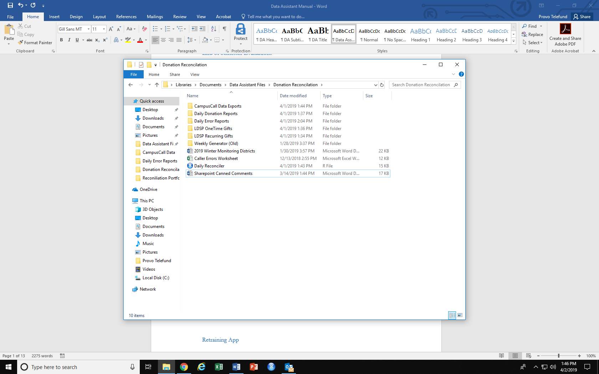Importantly, it does not matter what the name of the folder that contains this directory is or where it is stored on the computer. **However,the reconciler will not work** if this folder does not contain the Daily Reconciler R-script, the “CampusCall Data Exports”, “Daily Donation Reports”, “Daily Error Reports”, “LDSP OneTime Gifts”, and “LDSP Recurring Gifts” folders and are spelled exactly the way shown above.

It is also vital that all of the files being reconciled follow the exact naming conventions spelled out below. If this is not done correctly the files will not unreadable and the reconciler will fail. All date formats follow the standard MMDDYY numeric format.

Procedure for Running the Script

1. Place LDSP OneAccord reports into their corresponding folders.

The LDSP reports should be named “Telefund One-Time [date]” and “Telefund Recurring [date]” then copied into their corresponding folder. If one of these reports is missing (b/c there were none of that type of gift for that specific day) there is no need to put any file into that folder. If running the script for multiple days, you can copy multiple files in or one that covers the entire time range (the date on these should be the last date in the time frame).

1. Generate and place the CampusCall report in CampusCall Data Exports.

There is a data export in Reports Plus created specifically for the Reconciliation report. Under Data Exports in the Reports pane is a sub folder SCC Reports. In this folder is the “SCC Plg Report (Reconcile)”, click on it and the following 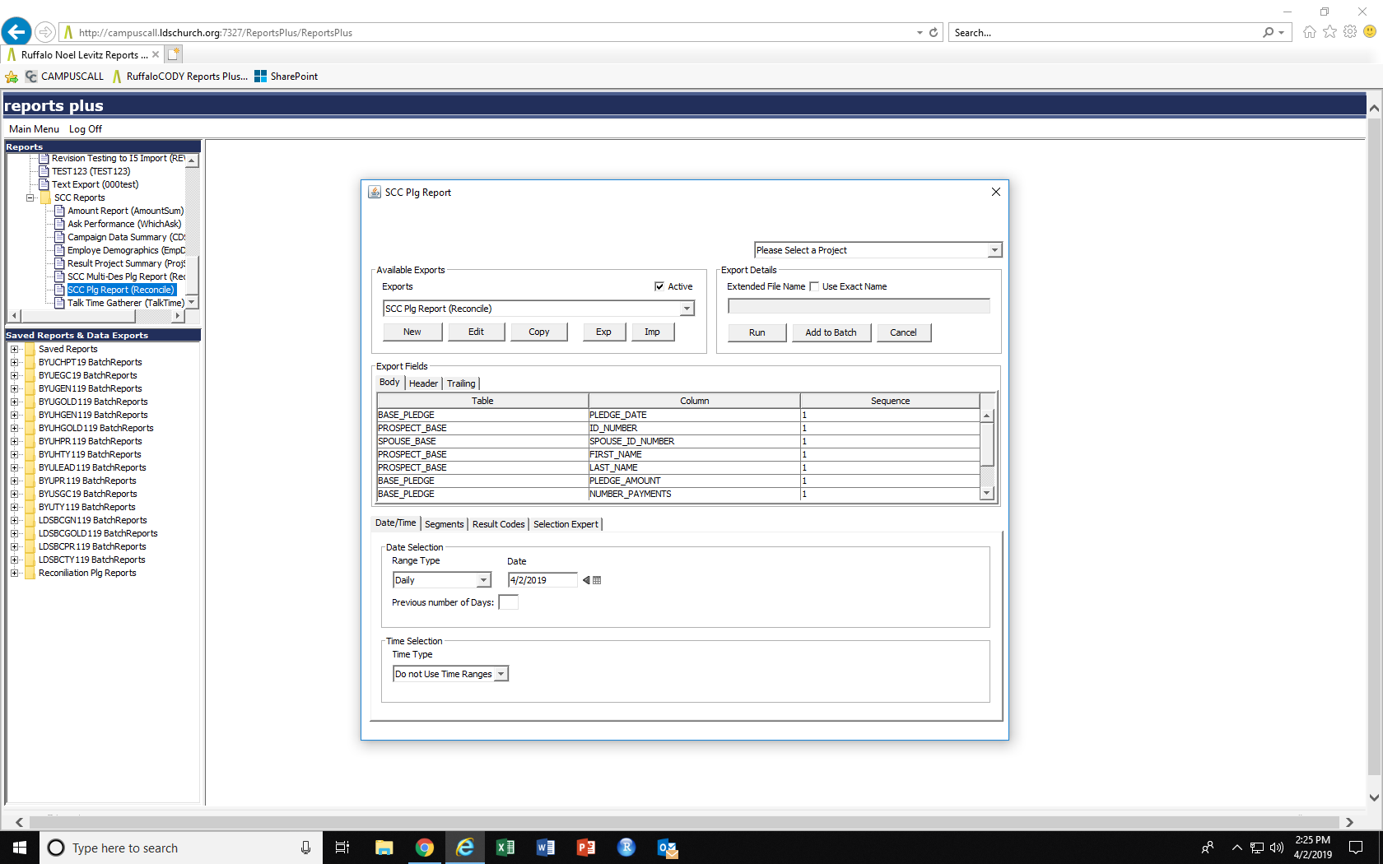interface will appear:

Within in this pane you can generate the Campus Call report. For specifics on how this works refer to the Campus Call manual.

* The report will have to be generated for every project called during the time period (this can be easily determined by using the segment browse feature in Online Statistics). The following will have to be repeated for each project after selecting it at the top.
* In the Date/Time tab set the time range to the date(s) to be reconciled. If reconciling one day the setting should be similar to what is shown at left. If reconciling for multiple days chose the Date Range option to set the date. It is only necessary to create one Campus Call report for any given time period though multiple reports for different days could be created.
* 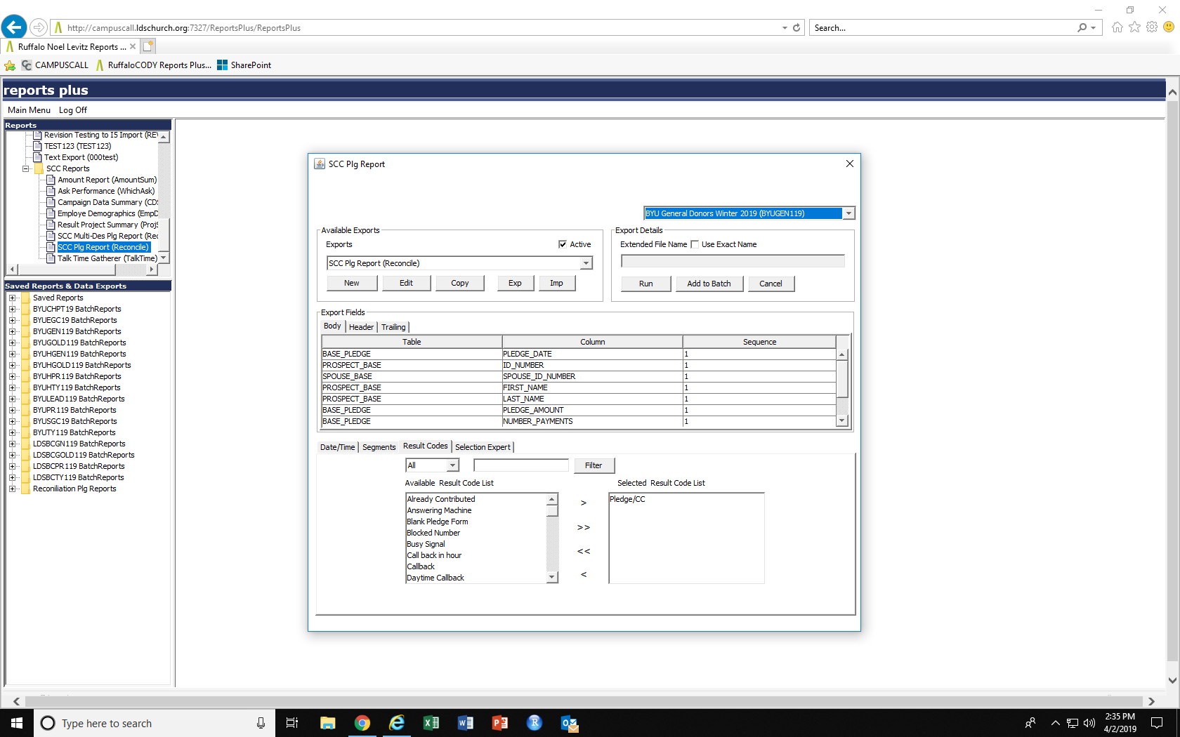On the Result Codes Tab set the result codes to match what is shown on the left lower image. Only Pledge/CC should be selected for this report.
* After making these changes click the run button. Do not change anything in the settings boxes that will pop-up. It doesn’t matter where the report is initally saved so long as there are no other CampusCall reports saved there. However, each project report must be saved in the same location. The first project report will save normally; all subsequent reports however will have an additional dialogue box asking if you want to append the dataset to the already present report. Click “yes” for all of these reports.
* Once all the projects have been reported change the name of the file to have the date on the end Ex. “(Reconcile) SCC Plg Report 011219” for January 12, 2019. Then place this file in CampusCall Data Exports folder.

1. Run the R-Script.

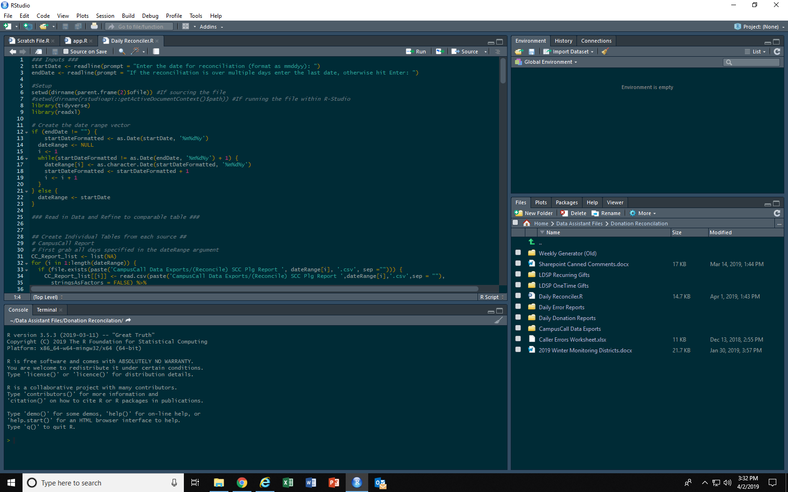Open the Daily Reconciler file. At the top of the script click the Source button.

After clicking the source button the Console (bottom left pane) will prompt you to input the date range being reconciled. The inputted dates should follow standard MMDDYY format. If reconciling a single day do not input anything for the second input, just hit enter.

The program will run and you will see a lot of text going through Console pane. If the program ran correctly the last line printed by the console will say “Report Generation Complete”. There may or may not be additional orange lines of text after that with any warnings that came up over the course of the program.

Occasionally the script will not run successfully. The next section contains some basic troubleshooting techniques to successfully generate the report.

Debugging Common Issues in the Script

Occassionally an error will occur during the script’s runtime. The majority of the bug’s in the code have been resolved, so this typically means there is an issue with the inputs. Here is a list of common error codes and what to do to fix it and have the script run properly:

## Retraining App

After the reconcilation report has been processed, any mistakes need to be fixed and the errant callers need to be retrained. To help with this process, so the Telefund Data Analyst does not have to do it by themselves, there is a retraining app on SharePoint to organize all of the needed retraining in one list.

The Telefund Data Analyst submits retraining requests to specific district leaders then reviews the retraining after the action has been taken.

In certain cases, a student error may require immediate action. For example when a donor is overcharged (whether they are charged too much in a single payment, or recurring payments when they only committed one time) or when a student uses the wrong ID number on a payment, the data analyst needs to act quickly to fix any mistakes before gifts are processed. The data analyst will email the finanace department to request a change on a donor’s gift.

Additionally, every Monday the data analyst should send an email to the finance department (currently the contact is Janae Winsor) to let them know it is okay to process the gifts that came in on Thursday, Friday, and Saturday.

Scheduling

## Updating the Schedule

1. Every week after 4:00 pm on Thursday turn-off employee sign-up from within the management options window in the scheduling app
2. Click the download schedule button. And use that in the excel workbook to create the printable next week schedule (See below)
3. Before Saturday, set the next week schedule as the current schedule and then clear the next week schedule